領家　対策！！(笑)

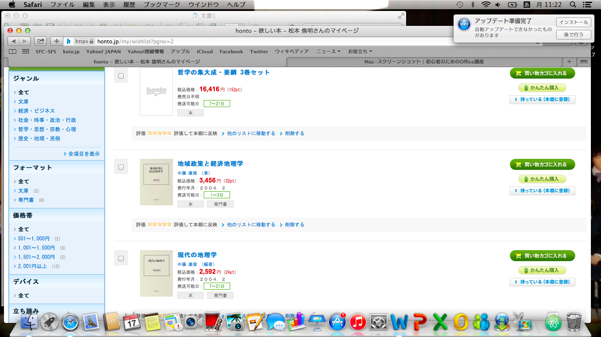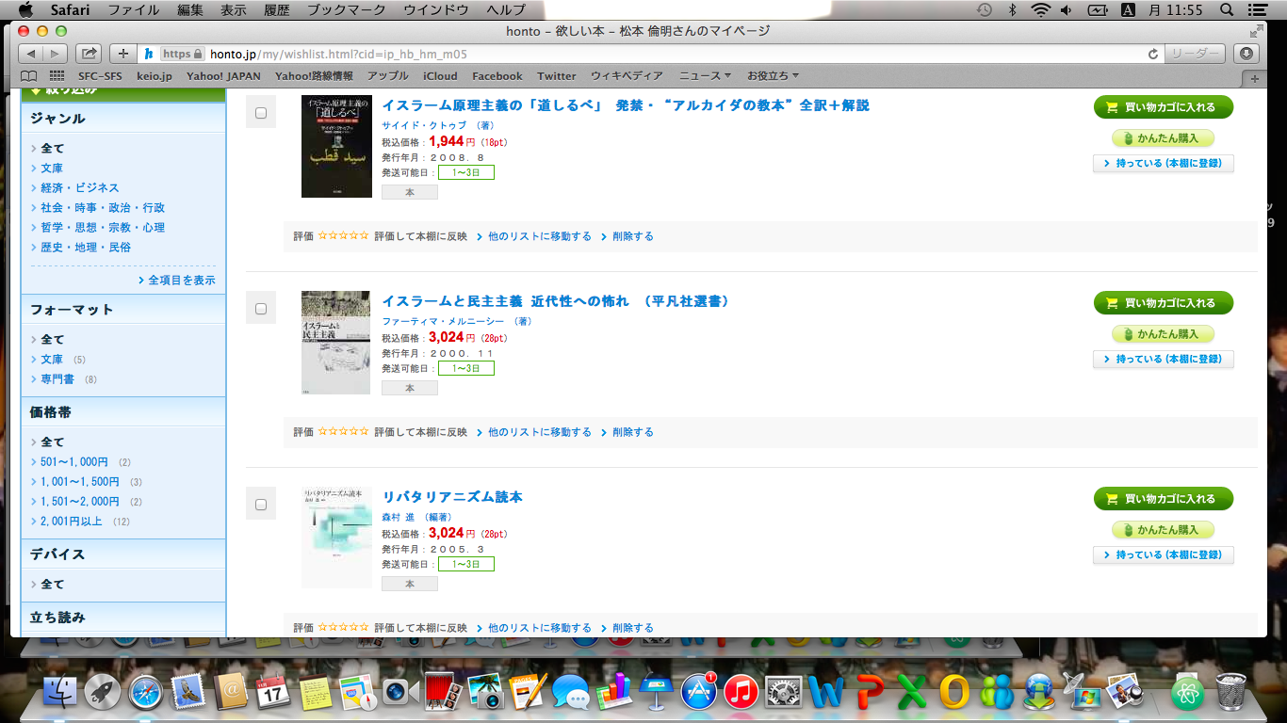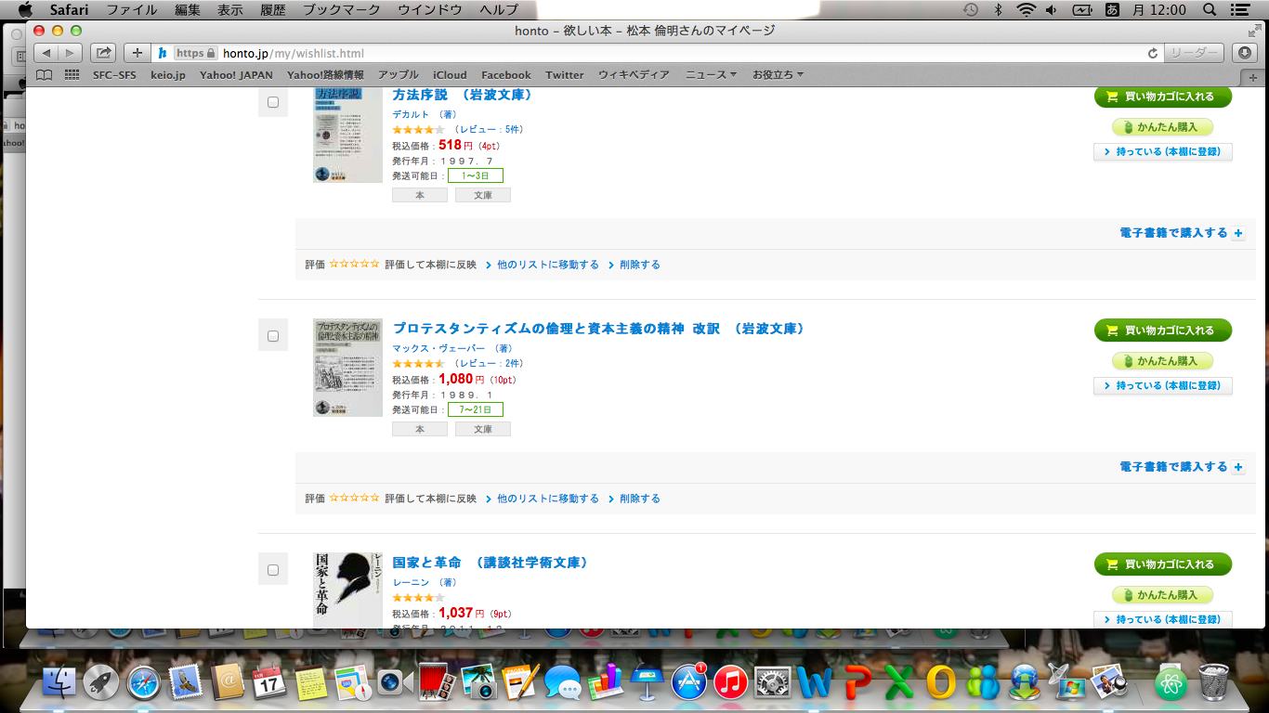

This is the point system of a bookstore. The letters “pt” next to the price is the point that you get when you buy the book. For example, when you buy the book “方法序説”, you get 4point.

Of course, you have to pay money to buy books, but you can also pay the point that you have gotten already. Then you have to pay at least 600 point.

I want to buy some books this month, and I have 930point now.

1. How many points do I have, after I buy all the books whose name has the word “Islam”?
2. How many points do I get, when I buy the most expensive book and the cheapest book?
3. Which book can I get without paying any money? Make list of all the books I can get.
4. I decided to buy the books below.

1 the books whose name has the word “Islam”

2 the pocket books

1. I have only bills and 100-yen coins and I want not to get any changes. How many points do I pay at least not to receive changes?
2. Then, how many points do I have, after paying for books in the question(4)①?